**FOR IMMEDIATE RELEASE**

|  |  |  |
| --- | --- | --- |
|  | Hyundai Motor America 10550 Talbert Ave. Fountain Valley, CA 92708  TEL: 714-965-3000  MEDIA WEBSITE: HyundaiNews.com  CORPORATE WEBSITE: HyundaiUSA.com | NewsBureauLogo |
|  |  |  |

Contacts: Christine Jew Jim Trainor

(714) 965-3547 (714) 594-1629

(657) 259-2704 (mobile) (714) 316-6421 (mobile)

#### [cjew@hmausa.com](mailto:cjew@hmausa.com) [jtrainor@hmausa.com](mailto:jtrainor@hmausa.com)

# ALL-NEW 2017 HYUNDAI ELANTRA MAKES ITS DEBUT AT

# THE LOS ANGELES AUTO SHOW

**New Elantra Combines Striking Styling, Segment-First Features**

**and Advanced Safety Technologies**

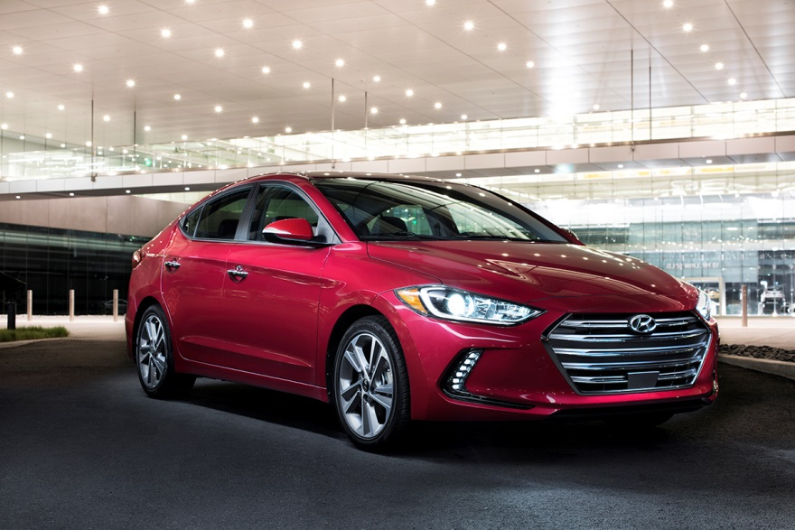

**LOS ANGELES, November 18, 2015** – Hyundai today reveals its all-new 2017 Elantra at the [Los Angeles Auto Show](http://www.hyundainews.com/us/en/media/presskits/44488/2015-los-angeles-auto-show). As one of Hyundai’s all time best-selling models, the new Elantra enters its sixth-generation building on the momentum and success of its proven award-winning formula and strong value proposition by offering a bold aerodynamic design with sophisticated styling, all-new efficient powertrains for enhanced fuel economy, better ride quality and noise insulation, and comprehensive safety with class-above features.

Assembled in both Montgomery, Alabama and Ulsan, South Korea, the new Elantra distinguishes itself from the compact car class with the addition of segment-first premium convenience and safety technologies, and is expected to receive a Top Safety Pick+ rating from the Insurance Institute for Highway Safety (IIHS) and a 5-Star Safety Rating from the National Highway Traffic Safety Administration (NHTSA). The 2017 Elantra will arrive at Hyundai dealers in January.

**STRIKING EXTERIOR DESIGN**

The new Elantra projects confidence with sculpted body forms complemented by smoothly contoured lines that reveal the underlying inspiration of Hyundai designers. Inspired by the concept of dynamic precision, Elantra’s architecture was a perfect platform for collaboration between Hyundai designers and engineers to blend advanced styling with functional aerodynamics.

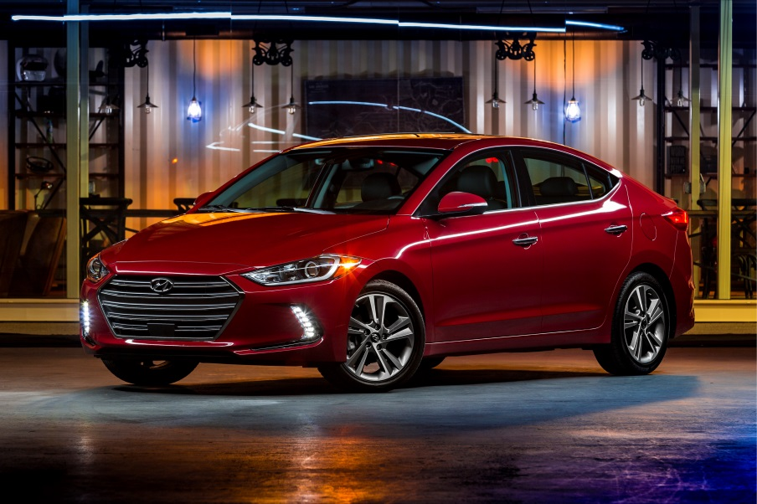

From the front, the new Elantra is defined by Hyundai’s signature hexagonal grille that projects a distinctive character when combined with its modern lighting signatures, including available HID headlights with Dynamic Bending Lights and unique vertical LED daytime running lights, which are firsts for Elantra. Elantra’s sporty lower front fascia integrates functional front wheel air curtains, a component that is derived from the Sonata Hybrid that helps manage air flow from the front of the vehicle and around the wheels to minimize turbulence and wind resistance. In addition, underbody covers, an aerodynamic rear bumper bottom spoiler and rear decklid designed with an expanded trunk edge contribute to Elantra’s 0.27 coefficient of drag.

Elantra features a sleek bodyside character line that accentuates a sweeping side window silhouette and striking side profile. Available premium features such as 17-inch alloy wheels, all-new LED door handle approach lights, side mirror LED turn signal indicators and LED taillights with high tech graphics add a level of sophistication and detail to this class-above compact sedan. The 2017 Elantra will be offered in eight exterior colors, five of which are new to the model. Elantra’s overall length has increased by just under an inch and its proportions are further enhanced by increasing its width by 1.0-inches, presenting a more athletic stance and stable appearance.

**2017 Elantra Improved Proportions**

|  |  |  |  |
| --- | --- | --- | --- |
| **Specification (in.)** | **2016 Elantra** | **Change** | **2017 Elantra** |
| Overall Length | 179.1 | +0.8 | 179.9 |
| Overall Width | 69.9 | +1.0 | 70.9 |
| Overall Height | 56.5 | - | 56.5 |
| Wheelbase | 106.3 | - | 106.3 |

**MODERN INTERIOR DESIGN**

On the inside, Elantra continues to depict a modern driver-oriented design that is optimized for intuitive control, improved interior roominess, high-quality materials and premium technology features. The contemporary interior design integrates premium soft-touch materials in key touch points and high-tech details to create an inviting and comfortable interior environment for all passengers.

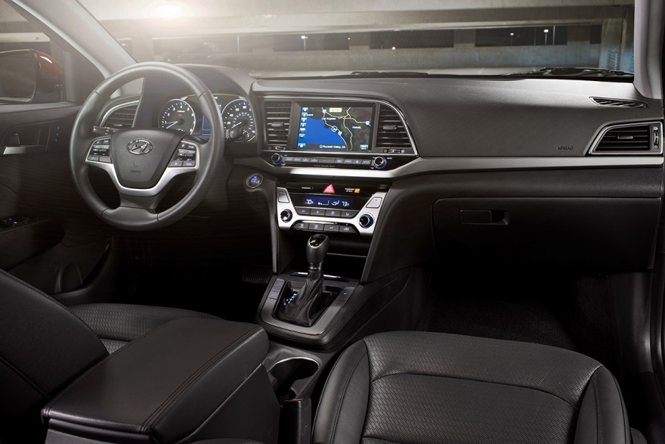

The wide design of the instrument panel provides a feeling of spaciousness and is available with a 4.2-inch color TFT LCD instrument display for improved driver visibility and functionality. The rest of the center stack is laid out in a horizontal design with buttons and controls placed in logical groups by function, and a slight seven degree tilt toward the driver for optimal ergonomics. Available premium convenience features such as a segment-first integrated memory system for the power driver seat and side mirrors, dual automatic temperature control with auto defogging system and auto-dimming rearview mirror further enhance driving comfort, along with advanced ergonomic front seats. The front seats feature high-tension lightweight seat frames for improved performance against collisions, and a multi-firmness seat pad to help reduce driver fatigue over long distances.

In fact, all of Elantra’s seats, covered in either cloth or available leather, are made of SoyFoam™, an environmentally friendly seating foam that substitutes petroleum based polyol with hydroxyl-functionalized soybean oil and optimizes the formulation/process to maximize mechanical performance. For added comfort and convenience, passengers enjoy available heated front and rear seats with a versatile 60/40 split-folding rear seat. Elantra also offers class-above total interior volume with improved front and rear headroom. At 110.2 cu. ft. of total interior volume, the 2017 Elantra is classified as a Midsize car by the EPA, which is a class above Mazda3, Ford Focus and some premium models.

**2017 Elantra Class-Above Interior Volume**

|  |  |  |  |  |  |
| --- | --- | --- | --- | --- | --- |
| **Specification (cu.ft.)** | **2017 Hyundai Elantra** | **2016 Ford Focus** | **2016 Mazda3** | **2016 Honda Civic** | **2016 Toyota Corolla** |
| Passenger Volume | 95.8 | 90.7 | 96.3 | 97.8 | 97.5 |
| Cargo Volume | 14.4 | 13.2 | 12.4 | 15.1 | 13.0 |
| Total Interior Volume | 110.2 | 103.9 | 108.7 | 112.9 | 110.5 |
| EPA Size Classification | Midsize | Compact | Compact | Midsize | Midsize |

**Premium Model Comparison**

|  |  |  |  |
| --- | --- | --- | --- |
| **Specification (cu.ft.)** | **2017 Hyundai Elantra** | **2016 Audi A4** | **2016 Acura ILX** |
| Passenger Volume | 95.8 | 90.6 | 89.3 |
| Cargo Volume | 14.4 | 12.4 | 12.3 |
| Total Interior Volume | 110.2 | 103.0 | 101.6 |
| EPA Size Classification | Midsize | Compact | Compact |

In addition to passenger comfort, improving interior cabin noise management and reducing road noise were top development priorities for Hyundai engineers. To reduce engine sound a hood insulator is equipped on the majority of Elantra models. Engineers also reduced the aperture size in the front dash panel by 25 percent, increased the thickness of the front door window glass, and added various sound absorption materials in all pillars, inner fenders and floorpan. In an effort to further improve NVH characteristics, engineers also applied plastic and rubber bushings to the front sub-frame and increased the bushings size of the lower control arm.

**REFINED & RESPONSIVE CHASSIS**

The 2017 Elantra is not only lighter than the outgoing model, but its rigid chassis is now reinforced with 53 percent advanced high-strength steel compared to 21 percent from the previous model, providing improved stiffness at a lower body weight. This increased utilization results in a 29.5 percent stiffer torsional rigidity and 25.3 percent greater bending strength, which bring improvements in vehicle ride and handling, quietness, durability and driving performance. Furthermore, the new Elantra increased structural adhesive application 40 times at higher stress points on the chassis and to reinforce welding areas. A component often found in aerospace applications, these structural adhesives also contribute to improved NVH and vehicle dynamics due to extra stiffness in the chassis. Hyundai engineers focused on these enhancements to develop a more rigid body structure in an effort to target top safety ratings by the IIHS and NHTSA.

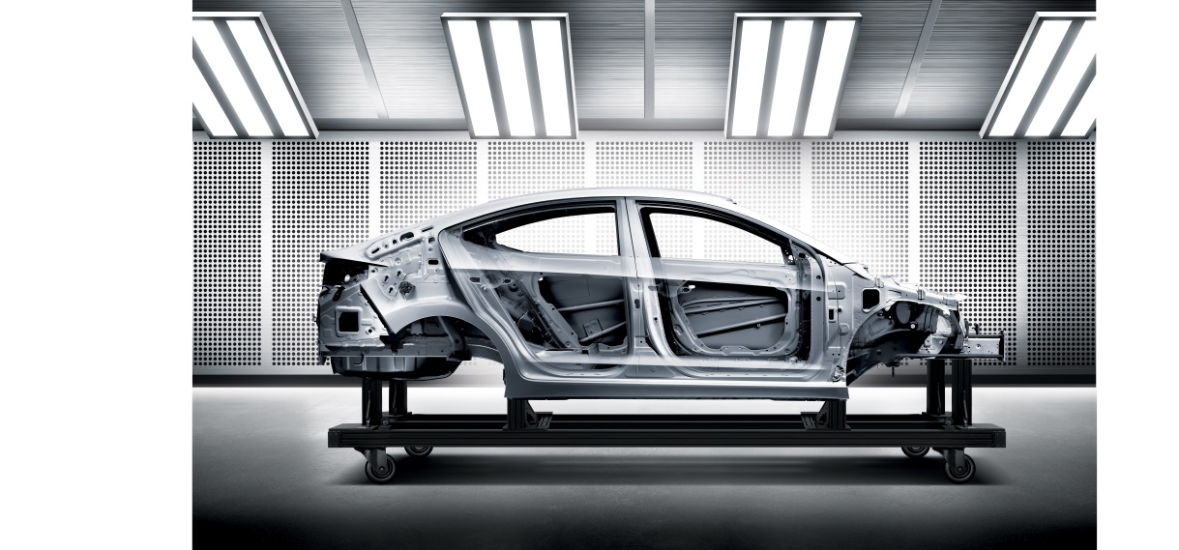

Improved ride comfort, handling and stability are achieved through Elantra’s redesigned rear suspension geometry that modifies the angle of the rear shock absorbers and changed the position of the coil springs on the coupled torsion beam axle. Additionally, an increase in rear bushing diameter helps to improve long term durability. Elantra’s front suspension uses an optimally designed McPherson strut with coil springs and gas shock absorbers along with a front stabilizer bar to help reduce body roll when cornering. The standard Motor-Driven Power Steering (MDPS) system instantly adjusts to changing driving conditions for greater precision and steering feel while improving fuel economy. Increased caster provides safe and reliable steering feedback at highway speeds.

**NEW EFFICIENT POWERTRAINS**

For 2017, the new Elantra receives two all-new powertrains designed for improved fuel efficiency and everyday drivability performance. The standard engine available on the base SE and Limited trim is a 2.0-liter Nu MPI Atkinson four-cylinder engine producing a peak 147 horsepower at 6,200 rpm and 132 lb. ft. of torque at 4,500 rpm (estimated). This Atkinson cycle-type engine reduces pumping loss by delaying the close timing of the intake valve in the compression stroke, therefore maximizing the expansion ratio – it is the only Atkinson cycle engine to be combined with multi-port injection in the compact class. This greater expansion ratio is made more efficient by allowing additional energy to be produced. Furthermore, this engine features a high compression ratio of 12.5.

Other enhancements include intermediate valve cam phasing that increases the operational range of the intake valves and helps to reduce pumping loss. High energy ignition coils are also adopted to increase combustion efficiency through increasing spark intensity. A new electronically controlled thermostat decreases pumping energy and allows the thermostat to open at a higher temperature. Finally, piston cooling jets are added to cool down the piston by spraying oil at the lower position of the piston resulting in knock stability and fuel economy improvements. All of this results in up to a 2.2 percent increase in efficiency for optimized fuel economy, and an anticipated 29 city / 38 highway / 33 combined mpg (internal estimate for 6-A/T).

This 2.0-liter Nu four-cylinder engine is paired with either a standard six-speed manual transmission (available only on the SE trim) or Elantra’s next generation six-speed automatic transmission. The new automatic transmission helps deliver dynamic performance with an overall 3.3 percent increase in efficiency for optimized fuel economy. A new valve body improves gear shift responsiveness and control, while an optimization in oil pump size aids in improving operating efficiency. A multi-clutch torque converter is also a new addition that allows more control over lock-up. Finally, rolling resistance and friction are minimized by adopting double angular ball bearings.

The second powertrain is an all-new 1.4-liter Kappa turbocharged GDI four-cylinder engine equipped on the Elantra Eco trim, available in Spring 2016. This engine produces 128 horsepower at 5,500 rpm and a robust 156 lb-ft. of torque at a low 1,400 ~ 3,700 rpm and will be mated to an EcoShift seven-speed dual-clutch transmission. The Eco trim is projected to achieve an unsurpassed estimated 35 mpg combined rating based on internal testing.

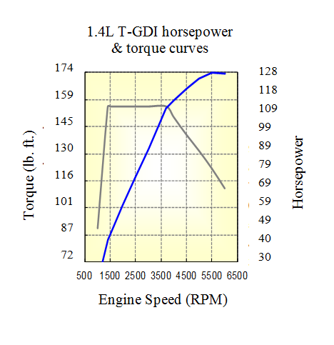

Other features of the 1.4L turbocharged GDI four-cylinder engine include an integrated cylinder head and exhaust manifold that improves fuel economy 5~7% at higher engine speeds. An optimized straight intake port increases tumble flow for fast combustion, suppressing knock tendency and improving fuel economy. The turbocharger is a single scroll design with an electric wastegate actuator. The optimized turbine and compressor employs a sophisticated scavenging strategy that improves low-end torque and response, while the electric wastegate actuator improves low-end torque and part-load fuel economy by reducing back pressure. Finally, the high pressure fuel injectors have six individually sized laser drilled holes to optimize the fuel spray pattern.

Both engines feature a multitude of friction-reducing and cooling components and high efficiency engineering features designed to enhance fuel economy and maximize performance. In addition, all Elantra trims are equipped with the new Drive Mode Select feature that adjusts both powertrain performance and steering effort, allowing the driver to customize the driving character by selecting from three modes: Eco, Normal or Sport, simply by touching a button on the center console.

**COMPREHENSIVE SAFETY**

In addition to the strengthened chassis, the 2017 Elantra makes structural improvements to the front side members that are now a hexagonal design and the dash-to-cowl connection has also been reinforced. The front apron to the A-pillar now features a straight and continuous load path and has hot stamping applied on the front side rear lower member. B-pillar assemblies feature partial softening hot stamping that start with a reinforcement section (150kgf grade) and then transition into a softening section (100kgf grade) to help absorb side impact. The rear doors also feature dual impact beams. A seven airbag system is standard, including a new driver’s knee airbag, along with Electronic Stability Control, Vehicle Stability Management, Traction Control, ABS and a Tire Pressure Monitoring System. The 2017 Elantra is expected to receive an IIHS Top Safety Pick+ and NHTSA 5-star safety rating.

New for 2017, the Elantra also offers a wide array of advanced safety technologies, often reserved for luxury cars, to provide another defensive safety layer for its passengers beyond the standard safety system. Available Automatic Emergency Braking with class-exclusive Pedestrian Detection is a technology that utilizes both the front forward facing radar and camera through sensor fusion to detect a vehicle or pedestrian, and warn the driver of a potential collision. If the driver does not react to avoid the impact, the system will apply emergency braking.

Additional Elantra-first safety technologies include available Lane Keep Assist, Blind Spot Detection with Rear Cross-Traffic Alert and Lane Change Assist, and a rearview camera, now with dynamic guidance. Lane Keep Assist uses a forward-facing camera to detect lane markings and will alert the driver if the vehicle drifts outside the lane without signaling. The system will apply corrective steering assistance if necessary, and is another active safety tool to assist Elantra drivers and help prevent accidents.

**INTELLIGENT TECHNOLOGY & FEATURES**

The 2017 Elantra truly advances ahead of the compact car class with innovative technology that enhances driver confidence and convenience, without the premium price. Elantra’s segment-exclusive hands-free Smart Trunk, allows Elantra drivers to conveniently open the trunk if their hands are full by simply approaching the rear of the vehicle with the key fob in a purse or pocket. An audible beep will sound three times, and the trunk will automatically open, making it easy to place items in the cargo area.

The new Elantra enhances the driver experience with available all new Dynamic Bending Light and Smart Cruise Control technology. Dynamic Bending Light (DBL) works in tandem with the HID headlights, so they turn-in with the direction of the steering wheel for better nighttime visibility and safety, while the additional High Beam Assist feature automatically dims the high beams when approaching vehicles are detected. Elantra’s Smart Cruise Control (SCC) makes highway and long distance driving more comfortable. Using a radar sensor mounted on the lower front grille, the SCC system maintains a set distance from the vehicle ahead in varied traffic conditions by automatically adjusting vehicle speed as needed.

**ADVANCED CONNECTIVITY AND MULTIMEDIA**

All Elantras come standard with iPhone®/USB and auxiliary input jacks and SiriusXM® satellite radio. New for 2017, the Elantra features two advanced infotainment systems beyond the base audio system that perfectly cater to the digitally connected – an available 7.0-inch Display Audio touchscreen system with rearview camera, and Hyundai’s next-generation 8.0-inch navigation system. Both multimedia systems are equipped with Android Auto for seamless and intuitive operation of the most commonly used smartphone functions including app-based navigation, streaming audio, voice-controlled search capabilities, plus any approved smartphone apps. Since smartphone integration requires a wired connection to the vehicle, Elantra provides an available second USB port for charging – the first application on a Hyundai vehicle.

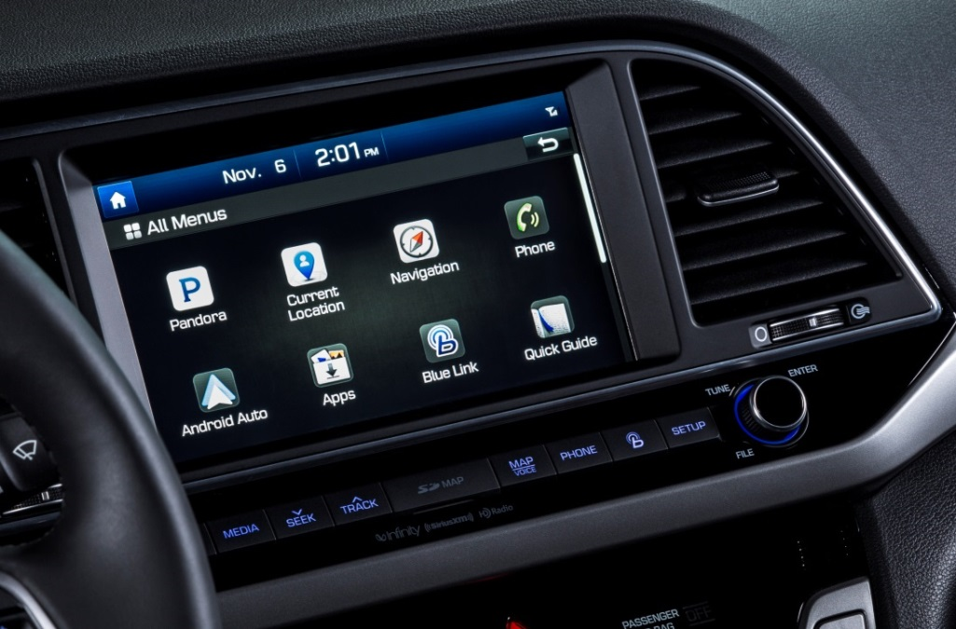

The advanced 8.0-inch navigation system features an enhanced display with improved touch sensitivity for touch and drag control, increased screen brightness for better daytime visibility, and a split-screen display showing map and music data. Both SiriusXM Satellite Radio and HD Radio® Technology are standard on this system. For additional convenience and connectivity, navigation-equipped Elantras offer pre-loaded apps, voice control functions, and premium SiriusXM features.

* Pandora® capability
* Real-time SiriusXM® Travel Link® three-month trial period, including traffic, weather, sports, stocks, fuel prices, even movie times, multi-cultural channels and presets recording capability
* SiriusXM® Tune Start – plays current song from the beginning when tuning into a preset channel
* “Eyes Free” Siri integration –voice control function to prevent driver distraction

For the first time, Elantra also will offer an eight-speaker Infinity premium audio system, including a center speaker and subwoofer. Furthermore, music lovers will appreciate Hyundai’s first application of Harman’s patented Clari-Fi™ music restoration technology. Clari-Fi™ analyzes digital audio files during playback and automatically rebuilds much of what was lost in the compression process. This delivers a musical experience closer to the artists’ original intent, with increased dynamic range for enhanced realism, and improved overall fidelity.

**NEXT-GENERATION BLUE LINK®**

The 2017 Elantra offers the next-generation Hyundai Blue Link system with enhanced safety, service and infotainment telematics. Blue Link brings seamless connectivity directly into the car with technology like Remote Start w/ Climate Control, Destination Search powered by Google®, Remote Door Lock/Unlock, Car Finder, Enhanced Roadside Assistance, and Stolen Vehicle Recovery. Blue Link can be easily accessed from the buttons on the rearview mirror, the web or via smartphone app. Some of these features can even be controlled via the latest Android Wear™ and new Apple Watch™ smartwatch offerings.

Blue Link is offered in three service packages: Connected Care & Remote is available on all models and Guidance is available on Navigation-equipped models. 2017 Elantras equipped with Blue Link offer one year of complimentary Blue Link Connected Care.

Connected Care package (complimentary for 1-year):

* Automatic Collision Notification (ACN) and Assistance
* SOS Emergency Assistance
* Enhanced Roadside Assistance
* Monthly Vehicle Health Report
* Maintenance Alerts
* Automated Diagnostic Trouble Code Notification (DTC)
* Service Link
* Blue Link App (smartphone, smartwatch)
* On-Demand Diagnostics
* Driving Information

Remote package:

* Remote Start with Climate Control
* Remote Door Lock/Unlock
* Remote Horn and Lights
* Car Finder via Mobile App
* Stolen Vehicle Recovery/Slowdown/Immobilization
* Vehicle Safeguard Alerts:
  + Geo-Fence
  + Valet Alert
  + Speed/Curfew Alert

Guidance package (Navigation-equipped models):

* Destination search powered by Google®
* Destination Send-to-Car by Google®

More details on specific Blue Link-equipped vehicles available at www.hyundaibluelink.com.

**HYUNDAI MOTOR AMERICA**

Hyundai Motor America, headquartered in Fountain Valley, Calif., is a subsidiary of Hyundai Motor Co. of Korea. Hyundai vehicles are distributed throughout the United States by Hyundai Motor America and are sold and serviced through more than 830 dealerships nationwide. All Hyundai vehicles sold in the U.S. are covered by the [Hyundai Assurance](http://www.hyundaiassurance.com/) program, which includes the 5-year/60,000-mile fully transferable new vehicle limited warranty, Hyundai’s 10-year/100,000-mile powertrain limited warranty and five years of complimentary Roadside Assistance. Hyundai Blue Link Connected Care provides owners of Hyundai models equipped with the Blue Link telematics system with proactive safety and car care services complimentary for one year with enrollment. These services include Automatic Collision Notification, Enhanced Roadside Assistance, Vehicle Diagnostic Alert, Monthly Vehicle Health Report and in-vehicle service scheduling.

For more details on Hyundai Assurance, please visit [www.HyundaiAssurance.com](http://www.hyundaiassurance.com/)

Please visit our media website at [www.hyundainews.com](http://www.hyundainews.com) and our blog at [www.hyundailikesunday.com](http://www.hyundailikesunday.com)

Hyundai Motor America on [Twitter](http://twitter.com/hyundai) | [YouTube](http://www.youtube.com/hyundai) | [Facebook](http://www.facebook.com/Hyundai)