**EMBARGOED UNTIL NOV.18 AT 1:05 PM**

|  |  |  |
| --- | --- | --- |
| 2004HyundaiLogoStacked_Blue288 | Hyundai Motor America 10550 Talbert Ave. Fountain Valley, CA 92708  TEL: 714-965-3000  MEDIA WEBSITE: HyundaiNews.com  CORPORATE WEBSITE: HyundaiUSA.com | NewsBureauLogo |
|  |  |  |

Contacts: Derek Joyce Jim Trainor

(714) 594-1728 (714) 594-1629

(714) 376-6653 (mobile) (714) 316-6421 (mobile)

#### [djoyce@hmausa.com](mailto:djoyce@hmausa.com) [jtrainor@hmausa.com](mailto:jtrainor@hmausa.com)

# HYUNDAI N 2025 VISION GRAN TURISMO CONCEPT TO HAVE NORTH AMERICAN DEBUT AT LOS ANGELES AUTO SHOW

**Developed exclusively for the Gran Turismo® racing video game franchise on PlayStation®, the Vision Gran Turismo Concept boasts an advanced hydrogen powertrain**

**LOS ANGELES, Nov. 18, 2015** – Today, Hyundai débuted its N 2025 Vision Gran Turismo Concept for the North American market at the [Los Angeles Auto Show](http://www.hyundainews.com/us/en/media/presskits/44488/2015-los-angeles-auto-show). This concept demonstrates the Hyundai brand’s unique perspective on future performance characteristics and was developed as one of the latest additions to the Vision Gran Turismo. The Vision Gran Turismo project invites automakers, design houses and leading brands to design special concept vehicles that showcase the future of automotive design, exclusively for Gran Turismo®, one of the most popular video game franchises. The N 2025 Vision Gran Turismo boasts a hydrogen fuel cell powertrain capable of generating an impressive 884 PS (872 HP), using an additional super capacitor system.

**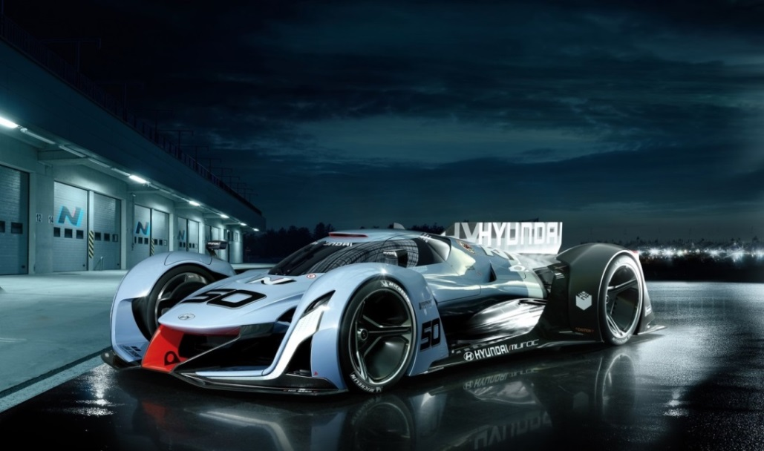**

**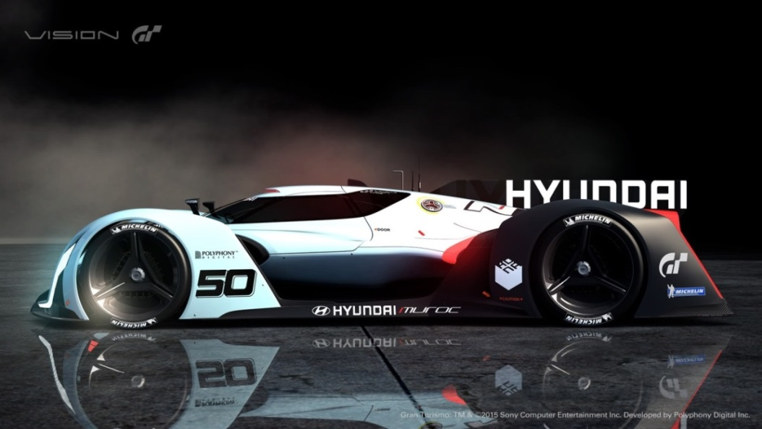**

**HYUNDAI MOTOR AMERICA**

Hyundai Motor America, headquartered in Fountain Valley, Calif., is a subsidiary of Hyundai Motor Co. of Korea. Hyundai vehicles are distributed throughout the United States by Hyundai Motor America and are sold and serviced through more than 830 dealerships nationwide. All Hyundai vehicles sold in the U.S. are covered by the [Hyundai Assurance](http://www.hyundaiassurance.com/) program, which includes the 5-year/60,000-mile fully transferable new vehicle limited warranty, Hyundai’s 10-year/100,000-mile powertrain limited warranty and five years of complimentary Roadside Assistance. Hyundai Blue Link Connected Care provides owners of Hyundai models equipped with the Blue Link telematics system with proactive safety and car care services complimentary for one year with enrollment. These services include Automatic Collision Notification, Enhanced Roadside Assistance, Vehicle Diagnostic Alert, Monthly Vehicle Health Report and in-vehicle service scheduling.

**About the Gran Turismo® Franchise**

Gran Turismo® celebrated its 15th anniversary in 2013, having first appeared internationally in 1998. The multi-award-winning franchise has been the most successful ever for PlayStation®, and in 2013 it also surpassed worldwide sales of 70 million units. Various iterations of Gran Turismo have been created for PlayStation®, PlayStation®2, PlayStation®3 and PSP (PlayStation®Portable) systems, and have always been regarded as the best and most authentic driving simulators ever created due to true-to-life graphics, authentic physics technology and design. Since the inception of Gran Turismo, famed creator Kazunori Yamauchi and Polyphony Digital Inc. in Japan have revolutionized the racing category as we know it today. His offerings provide the most realistic driving simulation in the industry and a unique medium for automotive manufacturers to showcase their products. Gran Turismo®6, the latest iteration of the game, was released on December 6, 2013.

For more details on Hyundai Assurance, please visit [www.HyundaiAssurance.com](http://www.hyundaiassurance.com/)

Please visit our media website at [www.hyundainews.com](http://www.hyundainews.com) and our blog at [www.hyundailikesunday.com](http://www.hyundailikesunday.com)

Hyundai Motor America on [Twitter](http://twitter.com/hyundai) | [YouTube](http://www.youtube.com/hyundai) | [Facebook](http://www.facebook.com/Hyundai)